1. In previous lecture, we saw what the properties are we can configure in our circuit breaker.
2. **Agenda**:
   1. We will set those properties to configure our circuit breaker.
3. 
   1. Last 10 calls will be considered based on which circuit will go into OPEN, HALF_OPEN or CLOSED states.
4. 
   1. If 50% or more of the last 10 calls are failed, switch goes into OPEN state.
5. 
   1. For 3000miliseconds (30seconds) switch will be in OPEN state to give time to the down service to recover then   
      automatically, it will come into HALF_OPEN state.
6. 
   1. After 30seconds OPEN state, we want switch come into HALF_OPEN state.
7. 
   1. We allow 5 calls in HALF_OPEN state.
   2. If 50% or more of those last 5 calls during HALF_OPEN state means 3 calls are failed then the switch will again go into OPEN state.
8. To check the current state of a switch, we can use actuator.
9. 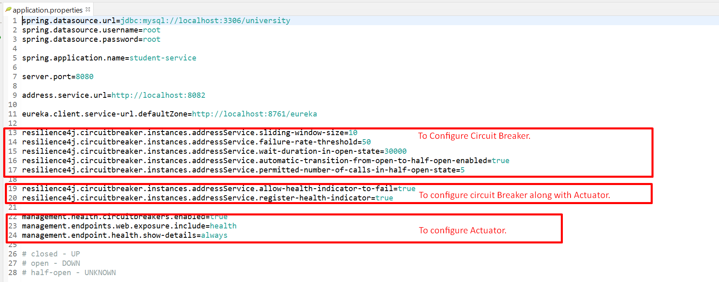
10. @CircuitBreaker  
    